**Social Media User Engagement Analysis Using Power BI**

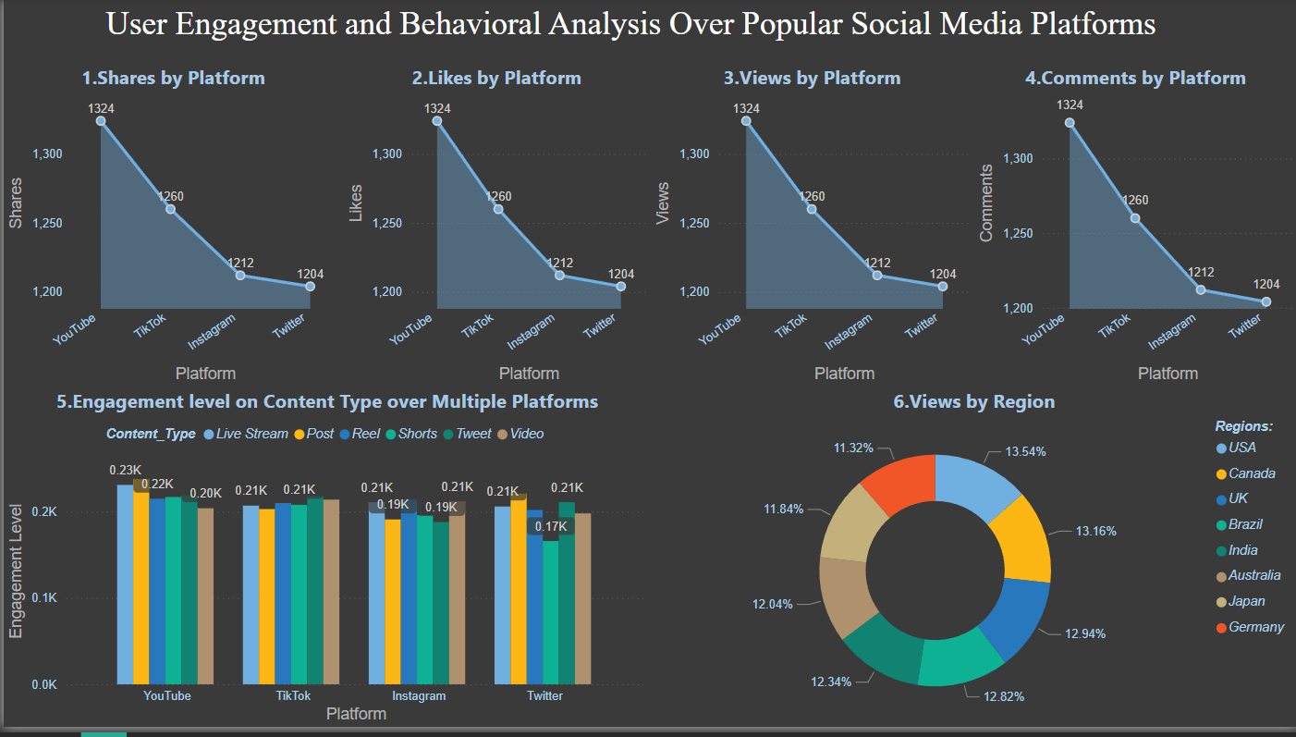

**1. Shares by Platform**

* **Description:** This bar chart represents the number of shares on YouTube, TikTok, Instagram, and Twitter.
* **Analysis:**
  + YouTube leads with 1324 shares, making it the most frequently shared platform.
  + TikTok follows closely with 1260 shares.
  + Instagram and Twitter trail behind with 1212 and 1204 shares, respectively.
  + This highlights YouTube's dominance in encouraging users to share content, possibly due to its diverse range of videos that cater to varied audiences.

**2. Likes by Platform**

* **Description:** The chart showcases the number of likes received on the same four platforms.
* **Analysis:**
  + YouTube again takes the lead with 1324 likes, mirroring its performance in shares.
  + TikTok remains second with 1260 likes, followed by Instagram (1212 likes) and Twitter (1204 likes).
  + The consistency between shares and likes suggests a strong correlation between the two metrics, emphasizing YouTube's popularity in driving audience appreciation.

**3. Views by Platform**

* **Description:** This chart compares the number of views received on YouTube, TikTok, Instagram, and Twitter.
* **Analysis:**
  + YouTube tops the chart with 1324 views, affirming its position as a widely consumed platform.
  + TikTok comes second (1260 views), followed by Instagram (1212 views) and Twitter (1204 views).
  + The high number of views on YouTube could be due to its longer-format videos, which might engage viewers for extended periods.

**4. Comments by Platform**

* **Description:** This chart measures the number of comments across the four platforms.
* **Analysis:**
  + YouTube leads once more with 1324 comments, indicating high audience interaction.
  + TikTok follows at 1260, Instagram at 1212, and Twitter at 1204 comments.
  + The elevated comment count on YouTube may reflect its focus on discussion and engagement through comment threads.

**5. Engagement Level on Content Type over Multiple Platforms**

* **Description:** This bar chart examines how various content types (Live Stream, Post, Reel, Shorts, Tweet, Video) perform in terms of engagement across YouTube, TikTok, Instagram, and Twitter.
* **Analysis:**
  + Engagement levels are relatively similar across all platforms and content types, ranging between 0.17K to 0.23K.
  + There doesn't appear to be a significant variance in interaction between different content types, suggesting a uniform appeal to audiences.
  + This consistency implies that the platforms have a balanced approach to promoting different content formats.

**6. Views by Region**

* **Description:** This pie chart reveals the percentage of views from various regions.
* **Analysis:**
  + Germany has the highest percentage of views at 13.54%, closely followed by Japan (13.16%) and Australia (12.94%).
  + India contributes 12.82% of the views, while Brazil (12.34%), the UK (12.04%), Canada (11.84%), and the USA (11.32%) are slightly lower.
  + The high numbers for Germany and Japan suggest strong user bases in these regions, perhaps due to regional content appeal or greater platform penetration.

**Overall Insight:**

The data collectively emphasizes YouTube's dominance across user engagement metrics like shares, likes, views, and comments. It also showcases a relatively uniform engagement across content types and highlights regional differences in user activity.